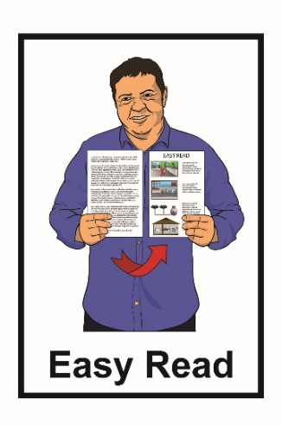


How to apply for
the Job Support Fund and
Training Support Fund



  - Published: March 2023

Before you start


This is a long document.


While it is written in Easy Read it can be hard for some people to read a document this long.

Some things you can do to make it easier are:

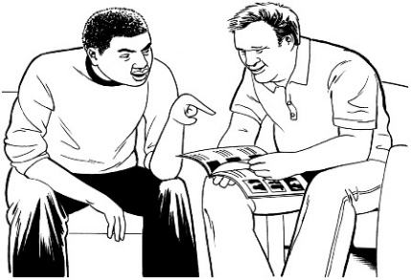
read a few pages at a time

have someone support you to understand it.

What you will find in here


Page number:

What this document is about 4


What is Job Support? 6
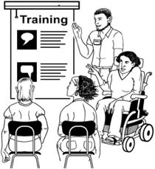

What is Training Support? 12


What things are not funded
by the Job and Training Support
Fund? 16


Who can get Job and Training
Support Funding? 18

Page number:


Who cannot get Job and Training
Support Funding? 23

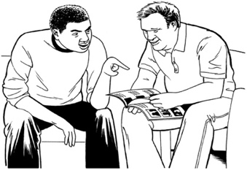
Getting support with applying for
Job and Training Support
Funding 24
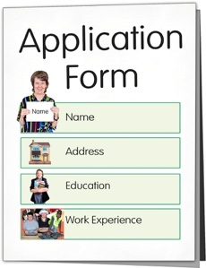

Applying for Job and Training
Support Funding 26


How to change your details
while you are getting support 44


Where to find more information 46

What this document is about


This Easy Read document is from the Ministry of Social Development.


It is information about their:

- Job Support Fund

- Training Support Fund.

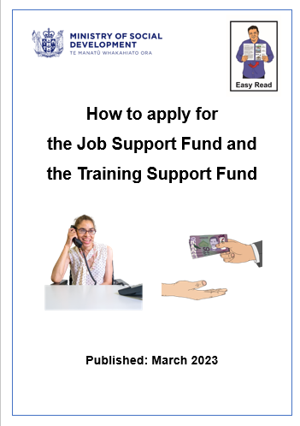
This Easy Read document explains what:
- these 2 Funds are
- who can apply for the Funds
- how to apply for the Funds.


Funds is money that is given by the Government to people who need it.



In this document we sometimes talk about the 2 Funds at the same time.

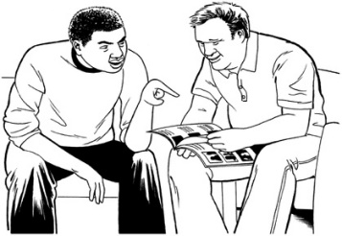
When we do this we call them Job and Training Support Fund.
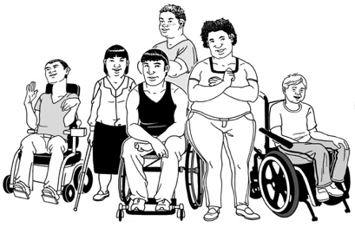

The Job and Training Support Fund is for people who have a:

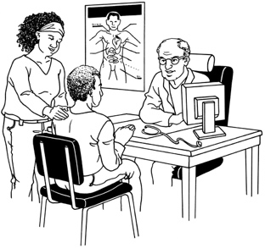
- disability

- health condition.

What is the Job Support Fund?

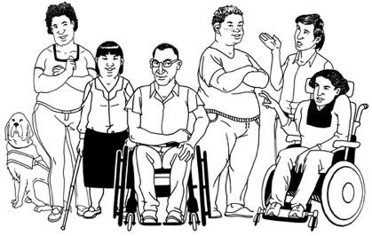
The Job Support Fund is for people who have a disability / health condition.


The Job Support Fund can assist you to:

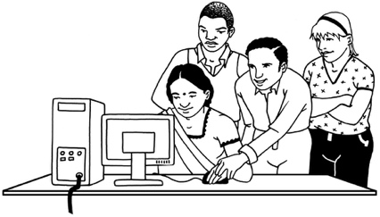
- get work

- stay in work.


You can also get support from this fund if you are self-employed.


Self-employed means that you:

- work for yourself

- you are your own boss.
The Job Support Fund can fund / pay for things like:

modifications to the place where you work
equipment to support you in your work.


Modifications are changes to the place where you work so you can work there.

For example adding a ramp for easy access into a work building.


Equipment could be things like:
- disability office furniture
- computer equipment.
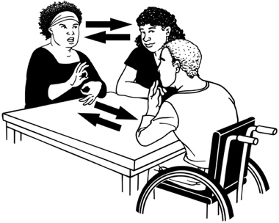
The Job Support Fund can also pay for things like:

a New Zealand Sign Language interpreter:


- in work meetings

- to support you to understand your work contract

- in professional development.

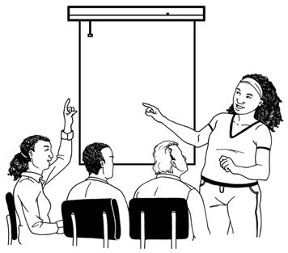
Professional development means training sessions with your work to teach you new work skills.

The Job Support Fund can also pay for things like:

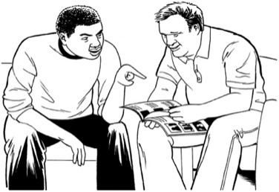
a support person who is a person you pay to support you with things like:


- reading / writing

- driving you to places to need to go if you cannot use public transport
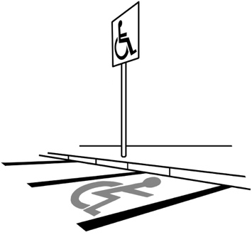
car parking costs while you are at work if you cannot use public transport.

The Job Support Fund can also pay for things like:

transport costs to get to / from work if you cannot use public transport

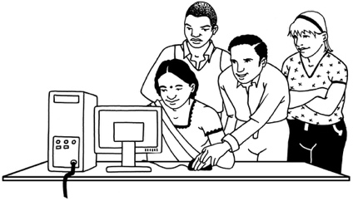
a productivity allowance which is money that is paid to your employer:

- while you are learning new skills for your job

- while they are setting up any support you need in the place where you work.

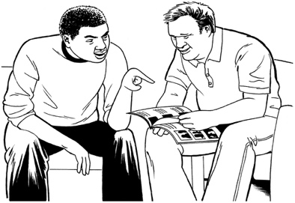
a job coach who is someone who can:

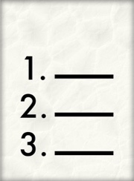
- assist you when you start a new job
Task list

- give you advice if the types of things you do in your job change.


If you do not know what type of job support you can get you can talk to the Support Funds Team at the Ministry of Social Development.


The Support Funds Team can do an assessment for you.

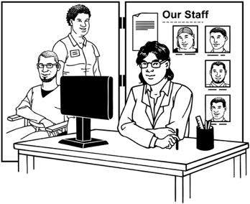
The assessment will check what kinds of support you need for your job.


You can find more information about how to get an assessment on the Work and Income website:

https://workandincome.govt.nz/supportfunds


If you have any questions you can find our contact details on page 46 of this document.

What is the Training Support Fund?

The Training Support Fund is for people who have a disability / health condition.


The Training Support Fund can pay for training to do a job.

Doing a training course can help you:

- get a job

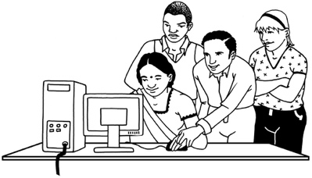
- stay in a job

- support yourself through self-employment.


The Training Support Fund can pay for things like:

equipment to support you with your training

a New Zealand Sign Language interpreter to support you to understand:

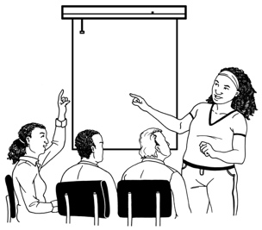
- classes you go to

- presentations you watch


- documents you need to read / use for your course.

The Training Support Fund can also pay for things like:

a support person who can assist you with things like:

- reading

- writing
- driving you to the place where the training is happening if you cannot use public transport
transport like the cost to get to / from the training place if you cannot use public transport.

If you do not know what type of training support you can get you can talk to the Support Funds Team at the Ministry of Social Development.

The Support Funds Team can do an assessment for you.

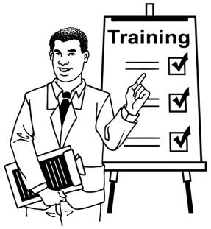
This assessment will look at what kinds of support you need to do your training course.

You can find more information about how to get an assessment on the Work and Income website at:

https://workandincome.govt.nz/supportfunds

If you have any questions you can find our contact details on page 46 of this document.

What things are not funded by the Job

and Training Support Fund?


There are some things that the Job and Training Support Funds cannot pay for.


The Job and Training Support Funds cannot pay for things you have already paid for.


This means you can only use Job and Training Support Fund for costs you have now / in the future.


The Job and Training Support Funds will not pay for things that all people would need to do your job / training course.

This means the Job and Training Support Funds do not pay for things like desks / chairs that everyone can use.


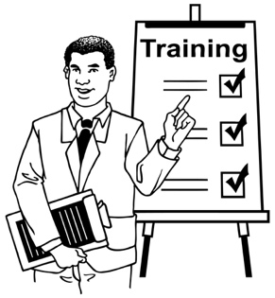
Training support also cannot be used to pay for your course fees.

Couse fees is money you pay to do the training course.

Who can get Job and

Training Support Funding?


To get Job and Training Support Funding you must be able to say Yes to all of these 5 things:

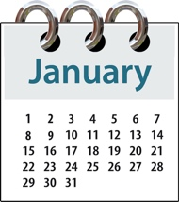
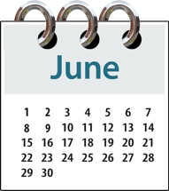
- You must have a disability / health condition that will last longer than 6 months

- Your disability / health condition must mean that you have extra costs to do your job / training.
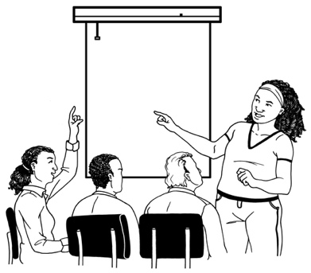

These costs must be costs that a non-disabled person would not have.
64
16

To get Job and Training Support Funding you must also be able to say Yes to these things:

- You must be aged between
16 years old to 64 years old.


- You must usually live in
New Zealand.


- you must be 1 of these:

- a New Zealand citizen

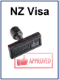
- someone who has a residence visa


- someone who has a temporary visa

- a refugee / protected person.

A New Zealand citizen is someone who can get a New Zealand passport.

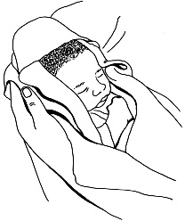

Many New Zealand citizens are born in New Zealand.

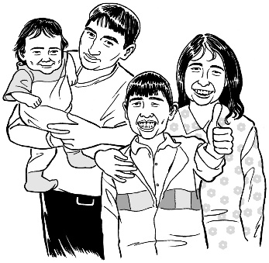
Some people who come to live in New Zealand from overseas also become New Zealand citizens.


A residence visa is an official document that says someone from another country can live / work in New Zealand for a long time.

A temporary visa is an official document that says someone from another country can live / work in New Zealand for short time.

Some people who have a temporary visa may also be waiting to find out if they can live in New Zealand as:

a resident

a refugee / protected person.

A refugee / protected person is someone who has come to New Zealand to be safe from harm in their home country.


To get Job Support Funding your job must:

- pay you at least minimum wage


- pay you about the same that a non-disabled person would get for the same job

- not be a job that is for disabled people only.

If you are self-employed to get Job Support Funding:
15


- you must work at least 15 hours in 1 week

- your business is going well enough to continue

- you can make money from your business.


To get Training Support Funding the training you get must be:


- training to assist you to get a job in the future

- training to make you better at doing a job you already have.

Who cannot get Job and Training

Support Funding?


Some disabled people cannot get Job and Training Support Funding.

You cannot get Job and Training Support Funding if:
you cannot say Yes to the 5 things on pages 18 to 19 of this document

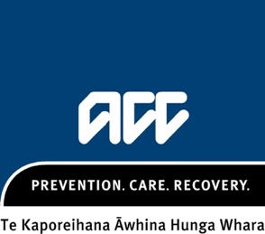
the Accident Compensation Corporation known as ACC is already paying for your job and training costs


the Ministry of Health is already paying for your job and training costs.

Getting support with applying for the

Job and Training Support Funds


You can apply for Job and Training Support Funding yourself.


You can also ask someone to assist you to apply like:

- someone in your whānau / family
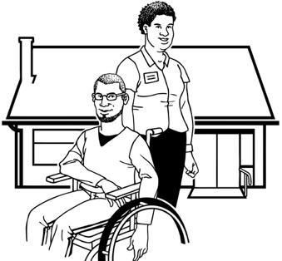
- someone you trust

- a support worker

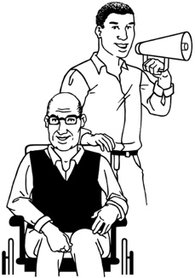
- an advocate.

An advocate is someone who can speak on your behalf.

You can find out more about who can assist you at the Work and Income website:

https://bit.ly/41RSc7L

Applying for Job and Training Support Funding


There is a checklist on page 39 of this document.

You can use the checklist to make sure you have got all the documents you need to send us.
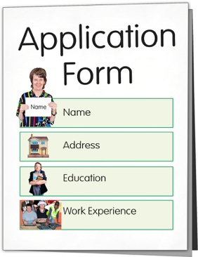

There are 4 steps to follow before you send us your application.

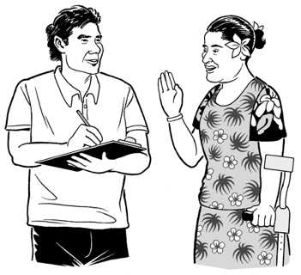
The 4 steps are for the person who is filling in the application form like:

you

someone who is assisting you.

Step 1: Fill in the application form

You can find the application forms on our website.


You can download the Job Support Application form at:

www.workandincome.govt.nz/documents/forms/job-support-application-form.pdf

You can download the Training Support Application form at:

www.workandincome.govt.nz/documents/forms/training-support-application-form.pdf

The application forms can be:

- printed out to fill in with a pen

- filled in on your computer.


If you choose to fill in the form on your computer you must:


print it out

sign it at the end.
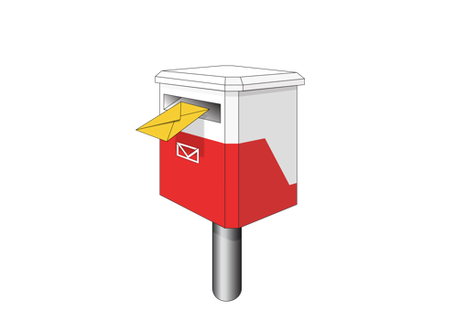

If you cannot print out an application form you can ask us to send you one:


- by sending us an email at:
Support_Funds@msd.govt.nz


- by calling us on:
0800 551 001
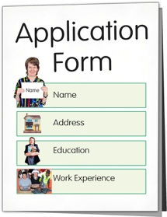

You can also call us to ask us to fill out an application form for you over the phone on:

0800 551 001


Someone will ask you about the details that need to go on the form so they can fill it out for you.


You can also use the New Zealand Relay Service to support you to contact us.


The New Zealand Relay Service is for people who:

- are Deaf / hearing impaired

- are deafblind

- find it hard to talk.

You can contact the New Zealand Relay Service on:

0800 771 771


It does not cost any money to phone this number.

You can find more about the New Zealand Relay Service at the website:

www.nzrelay.co.nz


Step 2: Show us documents about your disability / health condition

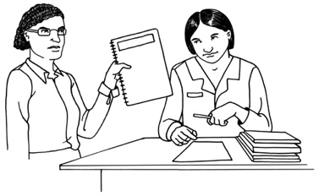
We will need to see some documents about your disability / health condition so we know what you need assistance with.

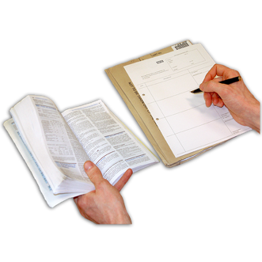
The documents can be one of the following:


- a medical certificate / letter from your doctor

- a report from an occupational therapist


a report from a psychologist

a document / letter from ACC.


An occupational therapist supports you to look after your body / mind through doing everyday activities.

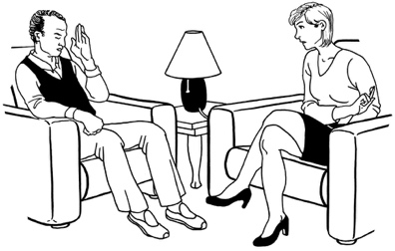
A psychologist knows a lot about how the brain works.
They can support you to look after your mind through talking things over with you.

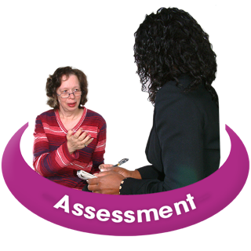
You can also send us documents that show you have a learning disability like a SPELD assessment.


For example you might have a learning disability that makes it more difficult for you to read.


The learning disability you have must be something you think you will always have / have for a long time.


If you have already given us one of these documents before you do not need to do so again.

This is because we may have your information / documents in our records already.

Step 3: Gather your supporting documents

We will need to see some other documents to support your application.


We need to see quotes / contracts to show us:

- what things you need support for

- how much these things cost.

These documents will tell us about the things you need.

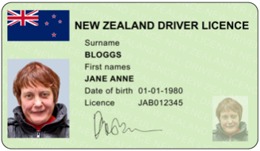
We need to see an identity document that shows us who you are like your:

- New Zealand drivers licence


- passport

- birth certificate

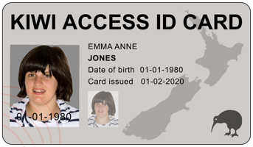
- Kiwi Access card.

Please do not send us the real documents.

Please send us a certified copy only.

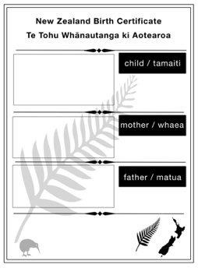

A certified copy is a copy of a document with a special stamp on it.

Only some people can use this special stamp.


Some people who can give you a certified copy of a document are:

- a Justice of the Peace

- a Court of Law

- a Notary Public.

You must take with you:

the original document

a photocopy of the document.

You can find a Justice of the Peace on this website:

https://justiceofthepeace.org.nz/Page/Search

You can find a Notary Public on this website:

https://notarypublic.org.nz/find-a-notary


If you have already applied for something with the Ministry of Social Development before you may not need to show us your identity documents.

This is because we may have your identity document in our records already.


We also need to see a document about your job / training course like:

- your employment contract

- a letter from your employer

- your registration for training / study

- something that shows you are self-employed.

Document check list


You can use this checklist to make sure you have all the documents you need from steps 1 to 3.


The completed application form

A document about your disability / health condition
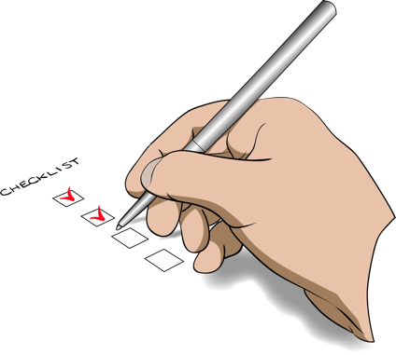
Documents about what you need support for / how much it costs
A certified copy of a document showing us who you are
A document about your job / training course.

When you have gathered all of these documents you are ready for Step 4.

Step 4: Send us your application

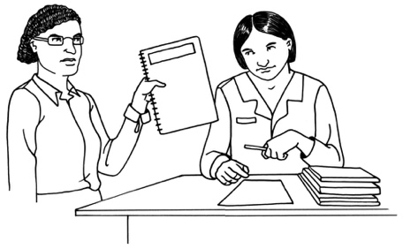
You should send us the completed application form with all your supporting documents.

There are 3 ways you can send us the application.


- You can scan all of the documents into your computer using:

- a scanner

- a scanning app on a smartphone.


You can send the scanned files by email to:

Support_Funds@msd.govt.nz

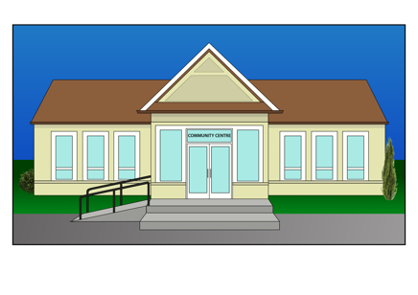

- You can also take your documents to a Work and Income service centre for us to scan for you.

You can find a Work and Income service centre on this website:

www.workandincome.govt.nz/about-work-and-income/contact-us/find-a-service-centre/

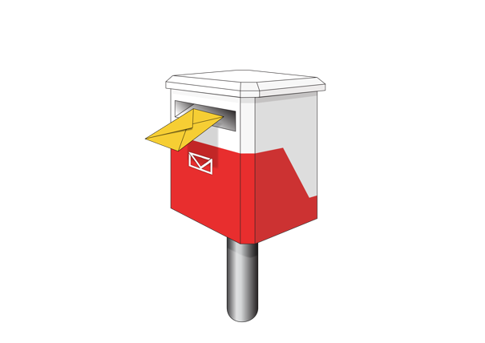
- You can post your documents to us at:


Ministry of Social Development

PO Box 1556

Wellington 6140

Attention: Support Funds


Please only send us certified copies of your most important documents.

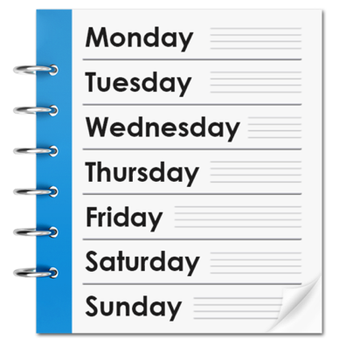
We will contact you in up to 5 working days after we get your application.

Working days are the days that most people go to work from Monday to Friday.
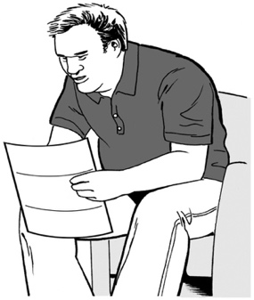
We will send you a letter to let you know if we accept your application.

If we accept the application we will tell you:

- what costs we can cover

- what support we can give you.


We will pay the costs to the business that offers the service / item you need.

How to change your details while you

are getting support


If you are getting job and training support something might change in your life that also changes what support you need.


These changes could be to your:

- job

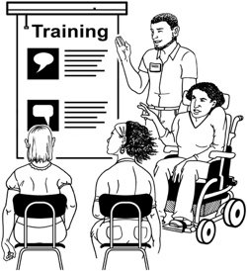
- training course

- disability / health condition


- contact details

- any other information we need to have about you.


If any of these things change please tell us as soon as you can.


You can tell us by phone on:

0800 551 001


You can email us at:

Support_Funds@msd.govt.nz


You can fill in a Change of Circumstances form.

The form can be found on this website:

https://workandincome.govt.nz/supportfunds

Where to find more information

You can find more information about the Job Support Fund and Training Support Fund on the Work and Income website at:

https://workandincome.govt.nz/supportfunds



You can contact us with any questions:

by email at:

Support_Funds@msd.govt.nz


by phone on:

0800 551 001
It does not cost you any money to call this number.

This information has been written by the Ministry of Social Development.


It has been translated into Easy Read by the Make it Easy Kia Māmā Mai service of People First New Zealand Ngā Tāngata Tuatahi.


The ideas in this document are not the ideas of People First New Zealand Ngā Tāngata Tuatahi.


Make it Easy uses images from:

- Changepeople.org



- Photosymbols.com

- SGC Image Works

- Huriana Kopeke-Te Aho.

All images used in this Easy Read document are subject to copyright rules and cannot be used without permission.

