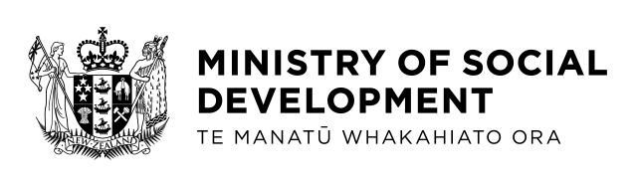
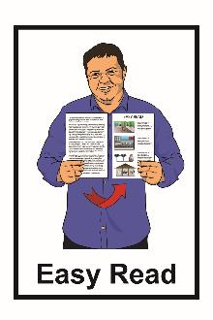

Dental treatment payment:

Getting support to pay

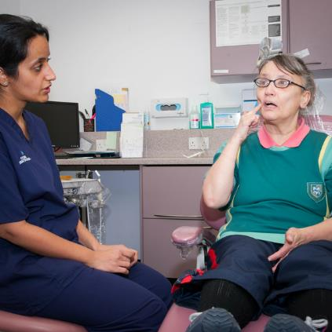
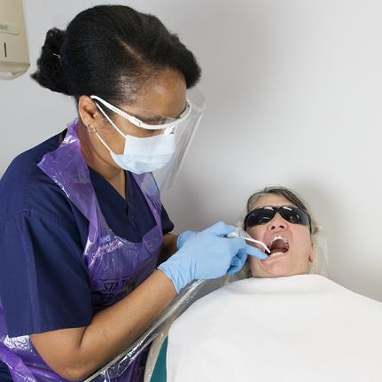
for the dentist

Published: May 2023

What you will find in this document

Page number:


What is this document
about? 3
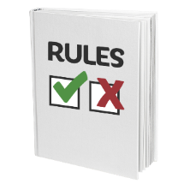

Who can get the dental
treatment payment? 5

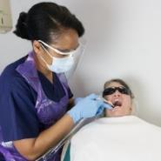
What dental treatments can
the payment be used for 9

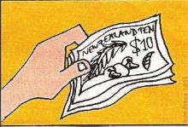
How much is the dental
treatment payment? 13


How to apply for a dental
treatment payment 15

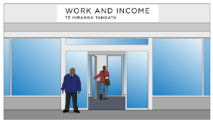
Page number:

How to apply in person 19


How to apply over the phone 20

How to apply in MyMSD 25

What is this document about?

This Easy Read document is about the Ministry of Social Development support to pay for dental treatment.
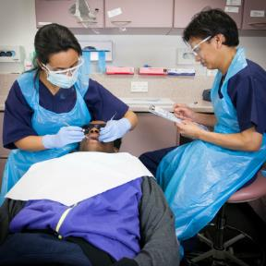

Dental treatment is when you need to visit a dentist because there is a problem with your teeth.

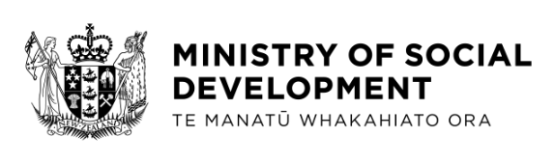
The Ministry of Social Development runs:


- Work and Income
- StudyLink.

The Ministry of Social Development is also called MSD.

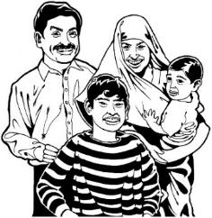
Work and Income offers support to:

- whānau / families

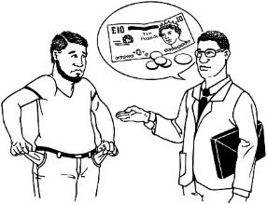
- people who do not earn much money

- people who do not have a job
- people who cannot work.

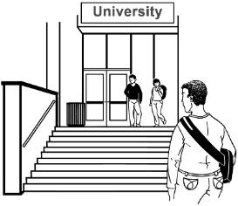
StudyLink offers support to New Zealand students studying at places like a university.

Who can get the dental treatment payment?

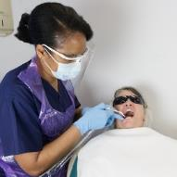

MSD has a payment called the dental treatment payment.

There are some rules about who can get the dental treatment payment from MSD.


Some of the rules are that you:

- are over 16 years old
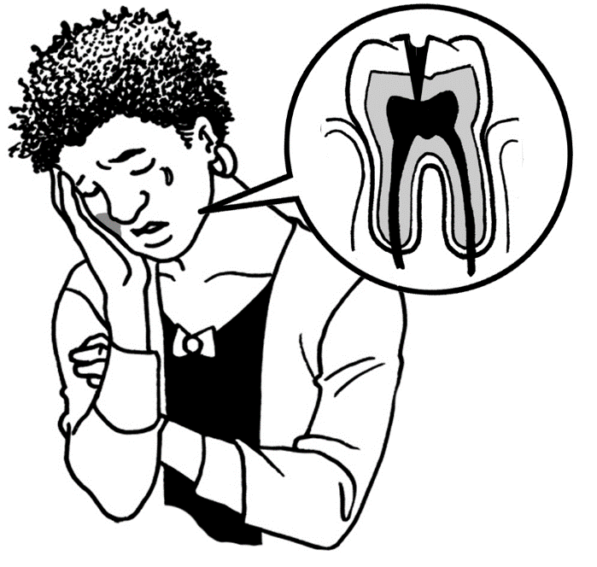
- need dental treatment right now

- are a New Zealand:

- citizen
or
- permanent resident.
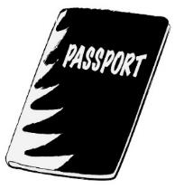
A New Zealand citizen is someone who can get a New Zealand passport.

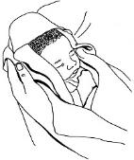
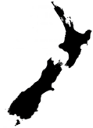
Many New Zealand citizens are born in New Zealand.
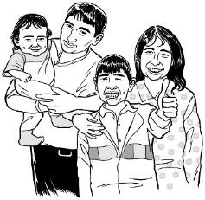

Some people who come to live in New Zealand from overseas also become New Zealand citizens.

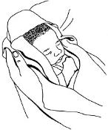
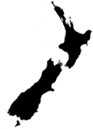

A New Zealand permanent resident is someone who:


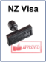
- was not born in New Zealand

- has been told by the Government they can live in New Zealand all the time.

There are some more rules that MSD use to decide if you can get the dental treatment payment like:

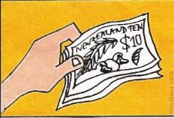
- how much money you earn
- how much money your partner earns

- any money you have saved

- what kind of dental treatment you need.

Another rule to decide if you can get the dental treatment payment is about your assets.


An asset is something that you own that you could sell to get money from like:


- more than one car
- a house you own but do not live in
- big things that cost a lot of money like a boat.

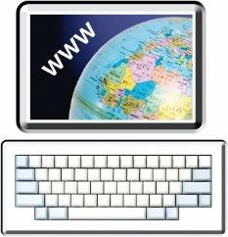
You can find out more about the rules for a dental treatment payment on the Ministry of Social Development website at:

https://workandincome.govt.nz/dental-treatment

What dental treatments can the

payment be used for?

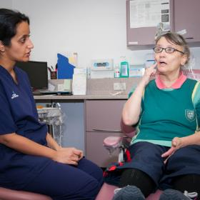
The MSD dental treatment payment can pay for:
- emergency dental treatment
- essential dental treatment.


Emergency dental treatment means you must have this done right now.

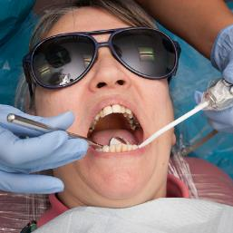
Essential dental treatment means that you need to have this done to make sure you stay well.

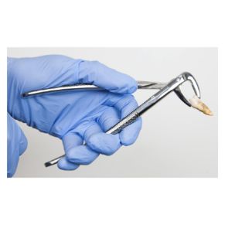
The MSD dental treatment payment can be used to pay for:
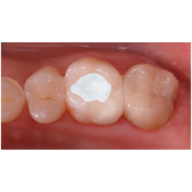
- extractions which means pulling a tooth out

- fillings to fix your teeth

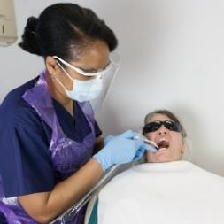
- treatments for infections

- root canal treatments for some teeth.

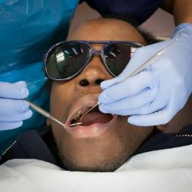
A root canal is when the dentist needs to take out the inside of the tooth.

The dentist then fills the tooth so you can keep it.

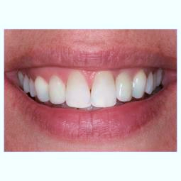
The dental treatment payment from MSD cannot be used to pay for:
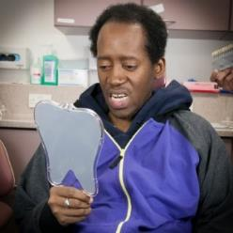
- regular check-ups to make sure your teeth are ok
- cosmetic treatments like whitening your teeth
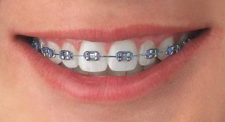
- teeth cleaning that is not for an infection
- orthodontic treatments like braces
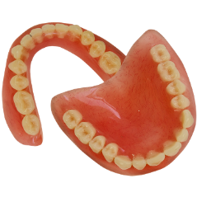
- root canal treatments on your back teeth
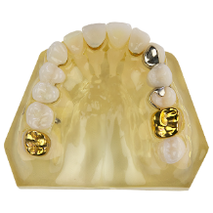
- dentures to replace missing teeth
- cast restorations like crowns.

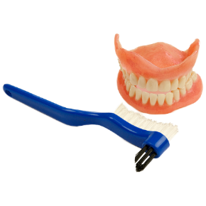
Dentures are removable false teeth.

They fit snugly over the gums to replace missing teeth.

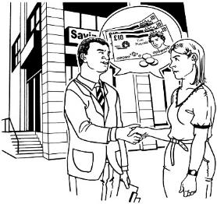
If you need support to pay for dentures you can apply to MSD for:
- recoverable assistance

- an advance payment of benefit.

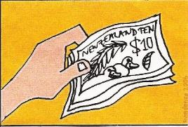
Recoverable assistance is money MSD can lend you that you will have to pay back a little each week.


An advance payment of benefit is a one-off payment to help you pay for something that you cannot pay for any other way.

You will have to pay this money back.

How much is the dental treatment payment?

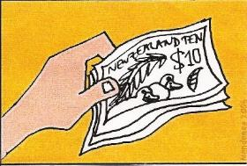
The dental treatment payment is up to 1 thousand dollars for each
1 year.

1 year means 52 weeks starting at any time.

It does not have to start in January.

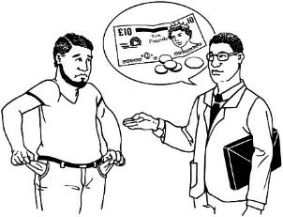
You do not have to pay this money back.

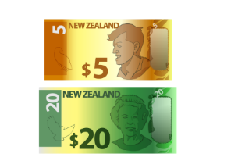
Any of the money that you do not use for your first dental treatment can be used for your next treatment in the same year.


If you need more than 1 thousand dollars in dental treatment in 1 year you can talk to:
- Work and Income

- StudyLink.

You might need to pay back any payments MSD gives you that is over 1 thousand dollars.

How to apply for a

dental treatment payment


The first thing you need to do is visit:

- your dentist
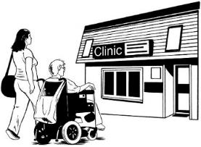
or

- the health agency who will be doing your dental treatment.


The people doing your dental treatment will need to fill out a
Dental Treatment information form.

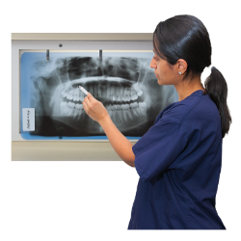
The Dental Treatment information form tells MSD about the dental treatment you need.


The people doing your dental treatment will already have this form.

They will fill it in once they have checked what you need.

The Dental Treatment information form asks:

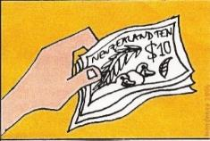
- what dental treatment you need

- how much it will cost
- who the dentist is
- anything else the dentist wants to tell MSD.


The information on the form helps MSD to know if they can assist you with a dental treatment payment.
The second thing you need to do is ask for a dental treatment payment by:
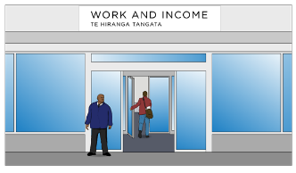
- visiting a Work and Income office

- calling Work and Income
- calling StudyLink

- applying in your MyMSD.


You can ask someone you trust to support you in filling out any forms you need to apply.
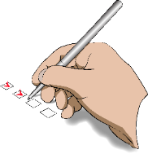

MSD will go through the next steps with you after you have applied.

As part of the next steps MSD will:
- tell you if they can give you a dental treatment payment
- tell you how you can pay your dentist.

How to apply in person

To apply for a dental treatment payment in person you can visit your local Work and Income office.


You will need to bring the Dental Treatment Information form from your dentist.


You can bring a support person if you like.


To find your local Work and Income office you can visit our website at:

https://workandincome.govt.nz/findus

How to apply over the phone

You can call Work and Income to apply for a dental treatment payment.


You can also use these phone numbers to call us if you have any questions.


If you are between 18 and 64 years old you can call us on:

0800 559 009


You can call us on this number:

- Monday to Friday from 7am in the morning to 6pm in the evening

- Saturday from 8am in the morning to 1pm in the afternoon.

If you are over 65 years old you can call Work and Income on:
0800 552 002

You can call us on this number:


- Monday to Friday from 7am in the morning to 6pm in the evening

- Saturday from 8am in the morning to 1pm in the afternoon.


If you are a student who gets money from StudyLink you can call us on:

0800 88 99 00

You can call us:

- Monday to Friday from
7am to 6pm

- Saturday from
8am to 1pm.

You can also contact us in other ways if you:

- are Deaf
- are hearing impaired
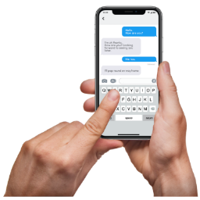

You can text us on:

029 286 7170

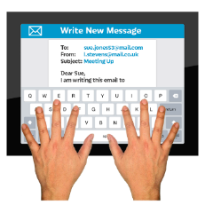
You can email us at:

MSD_Deaf_services@msd.govt.nz


If you find it hard to use the phone the New Zealand Relay service is for people who:

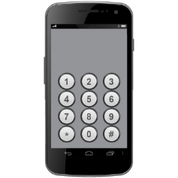
- are Deaf / hard of hearing

- are deafblind

- speech impaired / find it hard to talk.


You can find out more about the New Zealand Relay service at:

www.nzrelay.co.nz

How to apply on MyMSD

MyMSD is a Work and Income website that lets you manage your Work and Income account.

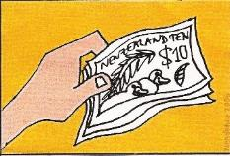
You can use MyMSD to apply for a dental treatment payment.

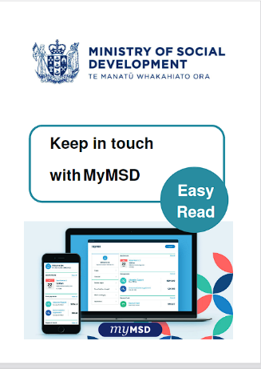
You can find out more about MyMSD in the Easy Read document:

Keep in touch with MyMSD

You can find this Easy Read document at:

https://bit.ly/3JfT4M3
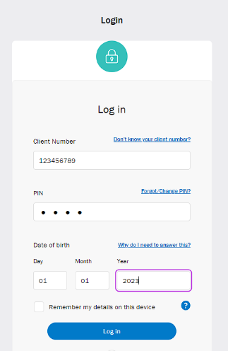
To log in to MyMSD you will need your:

- MSD client number
- MyMSD PIN number
- date of birth.

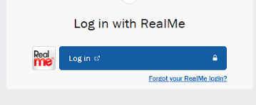
You can also use RealMe to log in to MyMSD by clicking the Log in with RealMe button on the log in page.


If you do not have a MyMSD account you can create one by clicking on Register for MyMSD at:

https://my.msd.govt.nz

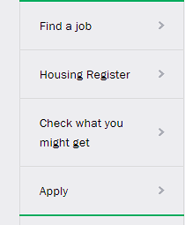
Once you have logged in to the MyMSD website you need to click on Apply on the left side of the screen.

On the next screen click on:
I need help with a one-off cost.
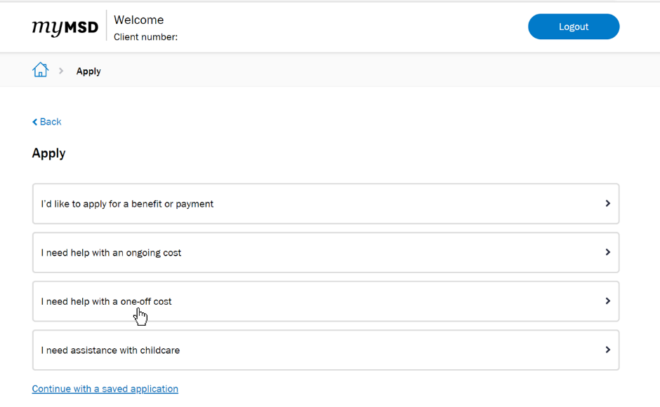


On the next screen:

- click the arrow next to Medical and dental
- click on the Dental costs checkbox
- click the Next button.

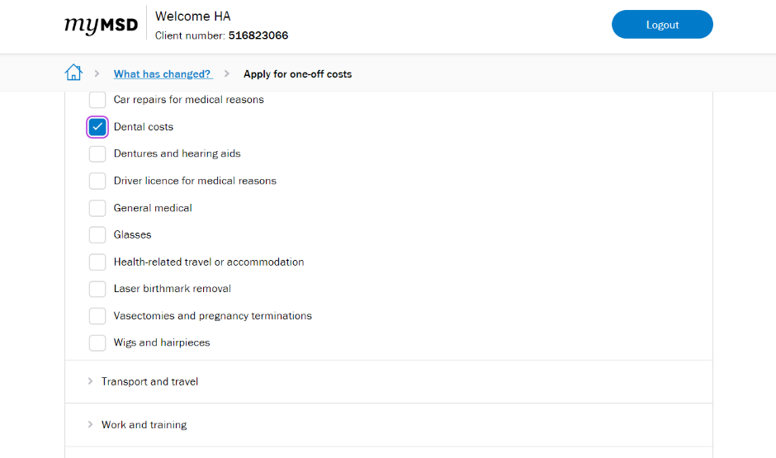

You then need to upload your Dental Treatment information form using the Get started button.

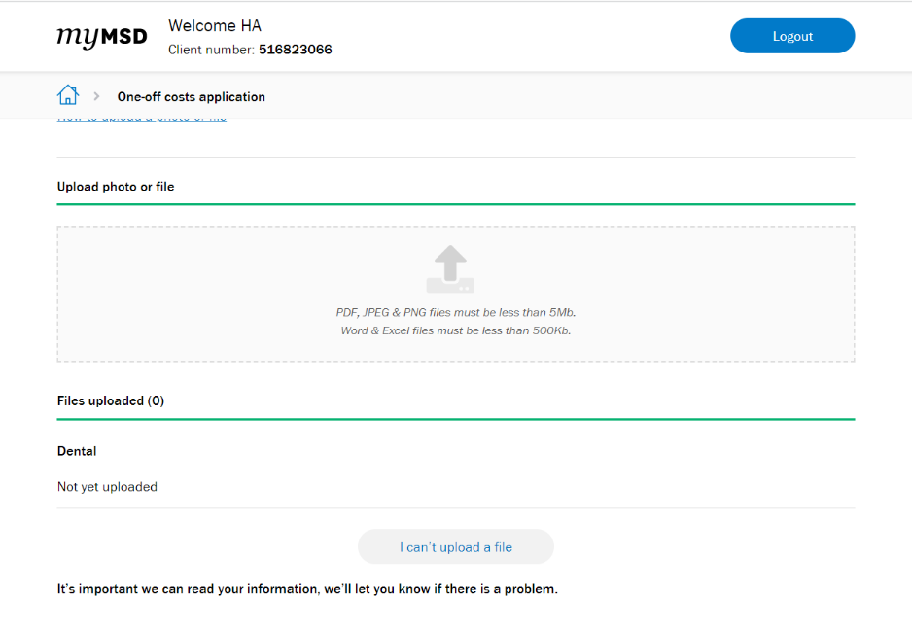


To upload your documents you:

- click Add

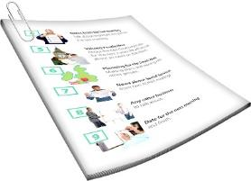
- choose a file from your device to upload
- click Add more if you need to upload another file.
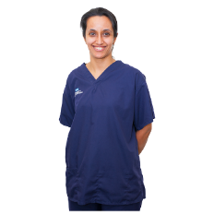
You need to make sure that the document shows:


- the name of your dentist
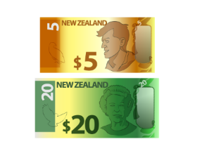
- the date
- the GST number if there is one

- the amount of money you are applying for

- the name of the person the treatment is for.

You will then need to answer some questions like:

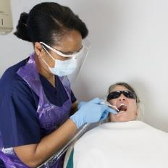
- why you cannot use your assets to pay for your treatment

- what kind of treatment you need like an extraction
- how much money you need

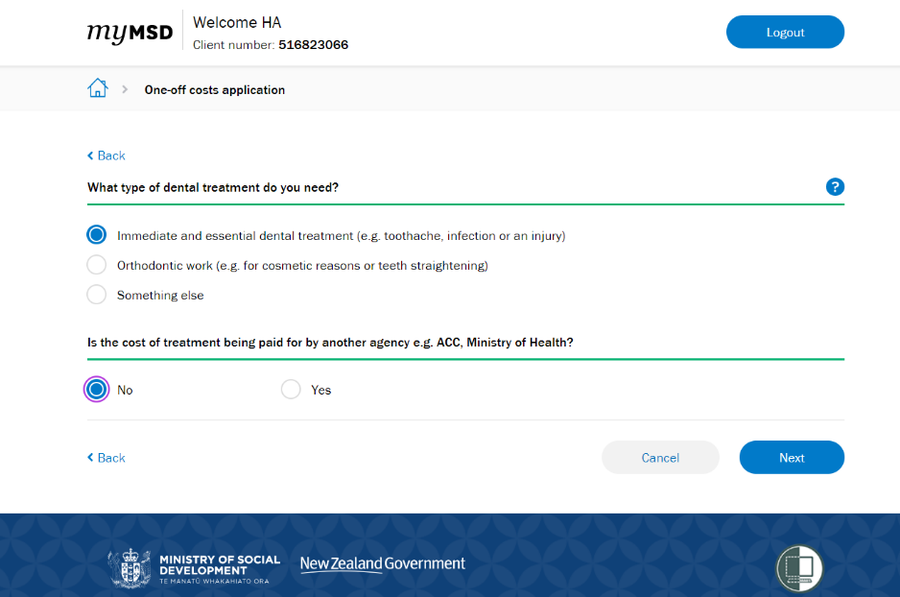
- what your MSD payment card number is.
You then need to search for your dentist by adding them as an MSD supplier.

A supplier is someone who is set up to do work for MSD.

Not all dentists are suppliers.
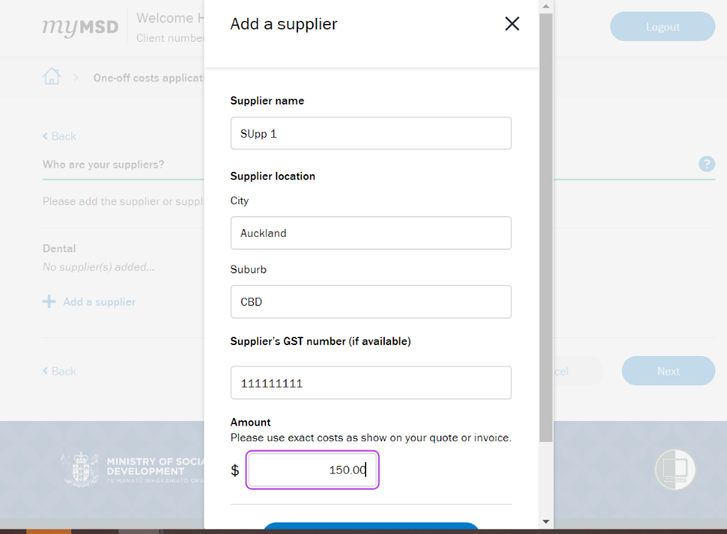

You then need to finish your application by:

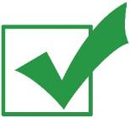
- checking the information you have given is right

- ticking the 2 checkboxes on the page
- clicking Confirm & submit.
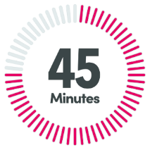
Check MyMSD at least 45 minutes after you finish your application to find out if MSD can give you the dental treatment payment.
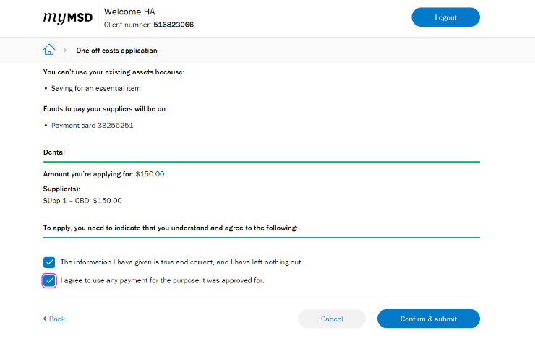
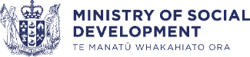
This information has been written by the Ministry of Social Development


It has been translated into Easy Read by the Make it Easy Kia Māmā Mai service of People First New Zealand Ngā Tāngata Tuatahi.


The ideas in this document are not the ideas of People First New Zealand Ngā Tāngata Tuatahi.
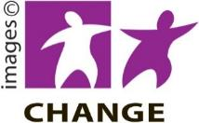
Make it Easy uses images from:

- Changepeople.org


- Photosymbols.com


- SGC Image Works

- Huriana Kopeke-Te Aho.


All images used in this Easy Read document are subject to copyright rules and cannot be used without permission.

