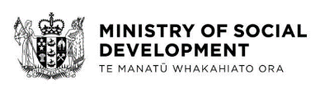

Our promise to you
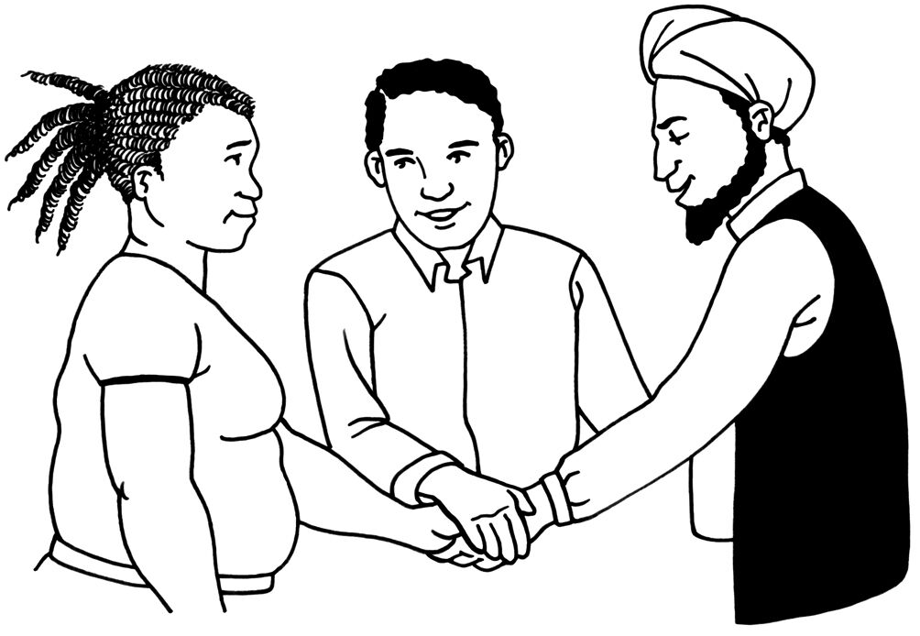

A guide about how we
will work with you

Easy Read
The Ministry of Social Development

The Ministry of Social Development is a government department.
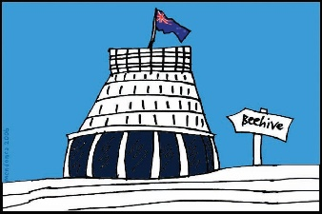
That means it is part of the government of New Zealand.
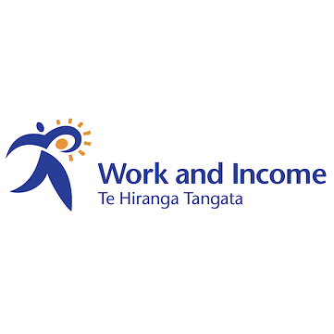
The Ministry of Social Development includes:
- Work and Income, which:
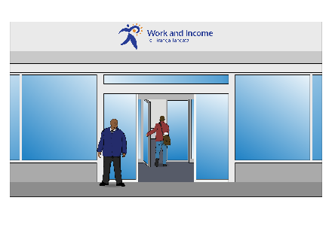
  - assists people who are looking for work
  - gives money to people to help them to pay for the things they need

- Studylink, which:
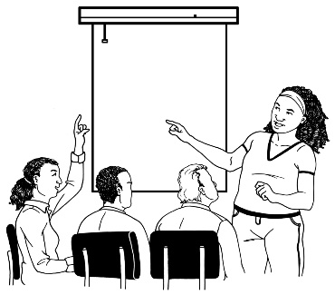
  - assists people who are doing study
  - gives money to people who are doing study to help them pay for the things they need.
We will get to know you
Ka mōhio ki a koe

The Ministry of Social Development will:
- get to know all about you and your needs

- make sure you know everything you need to know

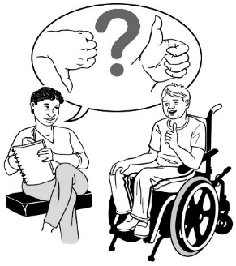
- use the things you tell us to make our service better

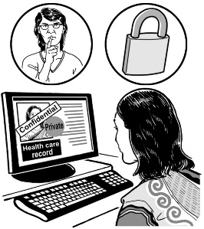
- respect your privacy.

Privacy means not sharing things about you that you do not want others to know.
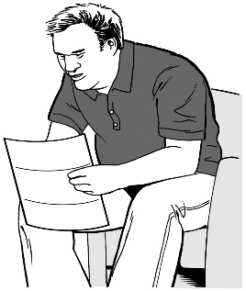
The Ministry will also:
- tell you how we will use your information

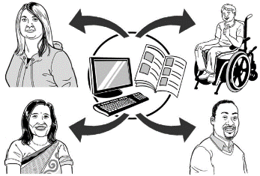
- tell you who we will share your information with.

We will support you
Ka tautoko i a koe

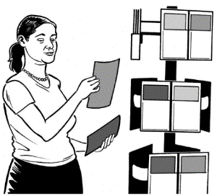
The Ministry of Social Development will:
- tell you about the things you can apply for that can help you
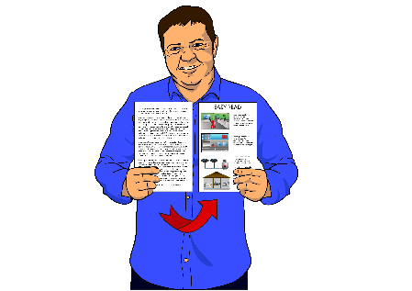

- make sure information is easy to understand

- try to make sure the information is the same every time you contact us

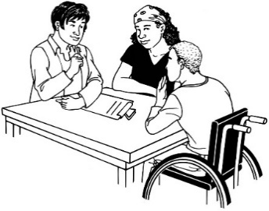
- help you as much as we can.

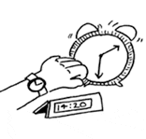
The Ministry will also:
- help you as fast as we can

- be honest if we make mistakes

- fix our mistakes.

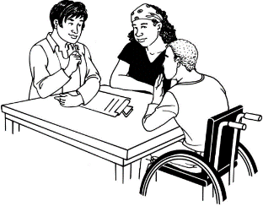
We will work with you
Ka mahi tahi

The Ministry of Social Development will:
- respect you

- respect the things that are important to you

- tell you about your choices

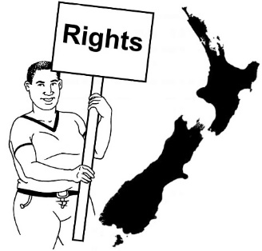

- tell you about your rights.

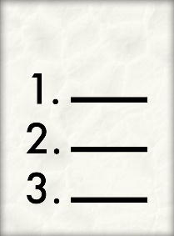
The Ministry will also:
- tell you about the things that you need to do
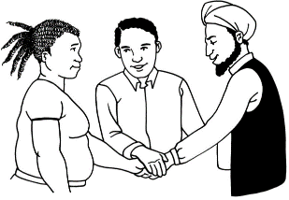

- work with you on goals that we both set

- do what we say we will.

Tell us how we are doing

You can tell us how we are doing by getting in touch with us on:

Website:
www.msd.govt.nz/feedback

or
Phone: 0800 559 009

